Practical 4 - 5 Logical Database Design

- Objective

To build a logical data model for the Reliance Rental Case Study.

- Your task

Form a group of 2-3 members to walk through the steps in the logical database design process to come up with an acceptable data model that satisfies the requirements stated in the case study attached. You can assume that the requirement specification given is for one user view.

Please refer to the instructions given in each practical to complete the data model.

- Deliverables

ER Diagram - submit in week 4
Relational schema – submit in week 6

- Rules

- This is a group assignment. Discuss with your group members and consult your tutor should you have any doubts.
- You can use any tools (eg Lucid chart, Visual Paradigm, MS Word/PowerPoint) to construct the ER diagram.
- Report can be type written on A4 size papers.
- Write your module group, team members’ names and admin numbers on the report.
- Participation marks will be given for teams who submitted the report on time.

Reliance Rental Case Study

The requirements collection and analysis phase of the database design process has provided the following data requirements for a company called Reliance Rentals, which rents out vehicles (cars and vans). The Company has various outlets (garage/offices) throughout Singapore. Each outlet has a number, address, phone number, fax number, and a manager who supervises the operation of the garage and offices at each site.

Each site is allocated a stock of vehicles for hire, however, individual vehicles may be moved between outlets, as required. Only the current location for each vehicle is stored. The registration number uniquely identifies each vehicle for hire and is used when hiring a vehicle to a client. Information stored on the vehicles for hire include: the vehicle registration number, model, make, engine size, capacity, current mileage, daily hire rate, and the current location (outlet) of each vehicle.

Clients may hire vehicles for various periods of time (minimum 1 day to maximum 1 year). Each individual hire agreement between a client and the Company is uniquely identified using a hire number. The data stored on a hire agreement includes the hire number, the client’s number, name, address, and phone number, date the client started the hire period, date the client wishes to terminate the hire period, the vehicle registration number, model and make, the mileage before and after the hire period.

After each hire a member of staff checks the vehicle and notes any fault(s). Fault report information on each vehicle is stored, which records the name of the member of staff responsible for the check, date checked, whether fault(s) where found (yes or no), the vehicle registration number, model, make and the current mileage.

The data stored on clients includes the client number, name (first and last name), home address, phone number, date of birth, and driving licence number. The client number uniquely identifies each client and the information stored relates to all clients who have hired in the past and those currently hiring a vehicle.

Information is stored on the staff based at various outlets including: staff number, name (first and last name), home address, home phone number, date of birth (DOB), gender, date joined the company, job title, and salary. Each staff member is associated with a single outlet but may be moved to an alternative outlet as required, although only the current location for each member of staff is stored.

The site managers provided some examples of typical queries that the database application must support.

- The names and telephone numbers of the Managers of each office.
- The total no. of male and female clients (pass and present).
- The average mileage driven by each client.
- The most popular make and model of the vehicles that are hired.
- The registration number of cars that have had no faults found.

You may make any additional assumptions if necessary. State your assumptions clearly.

Practical 4

Step 1- Build Logical Data Model

Follow the following steps to complete this practical:

Step 1.1 Identify entities
Step 1.2 Identify relationships
Step 1.3 Identify and associate attributes with entities or relationships
Step 1.4 Determine primary key attribute(s)
Step 1.5 Remove features incompactible with the relational model
Step 1.6 Check model supports user transactions by indicating transaction path in the ERD.

Deliverable: ER diagram

Practical 5

Step 2 – Derive and validate relations

Derive relations for the logical data model based on the following guidelines:

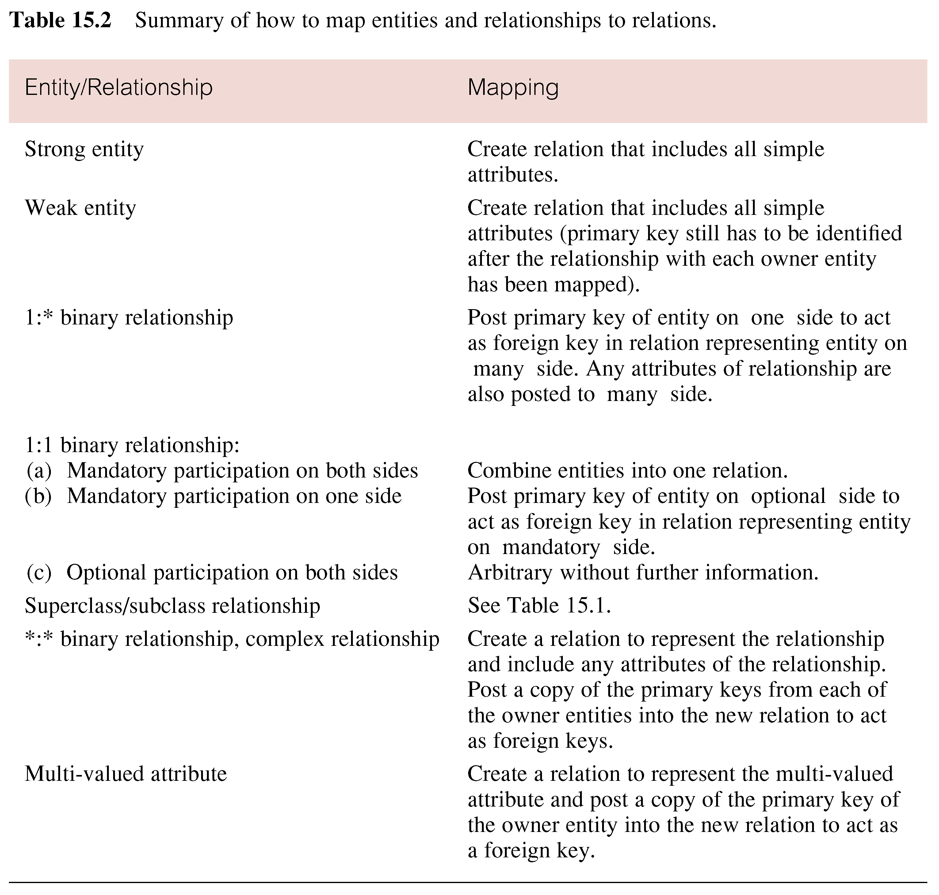

Deliverable: Relational schema

